9 Days Masai Mara, Lake Nakuru, Manyara, Ngorongoro & Serengeti Budget Safari:

Starts from Nairobi to Masai Mara game reserve, that boasts of wildlife in their natural setting, a rich culture and beautiful landscapes. We head to Lake Nakuru National park, that is gorgeous year in year out as it flaunts the flamingos, hosts the rhinoceros both white and black, endangered giraffes, lions, leopards and many more. More magic is found in Lake Manyara in Tanzania, as we view more wildlife. We top the excitement with a visit to the Ngorongoro crater then finish up with Serengeti National park with great memories.

Day 1: Nairobi-Masai Mara.

Pick up from your hotel in the morning at 7.30 am and head west for Maasai Mara Game Reserve for lunch at your tented camp followed by afternoon game drive in the game reserve which is Kenya’s finest wildlife sanctuary.Including migrants, well over 450 species of animals have been recorded here. Although July, August and September are the months when the Mara plains are filled with migrating wildebeest and zebra, there is also resident wildlife year round. The famous Maasai tribesmen live within the dispersal area of the game reserve. Dinner and overnight at the Masai Mara Camp.
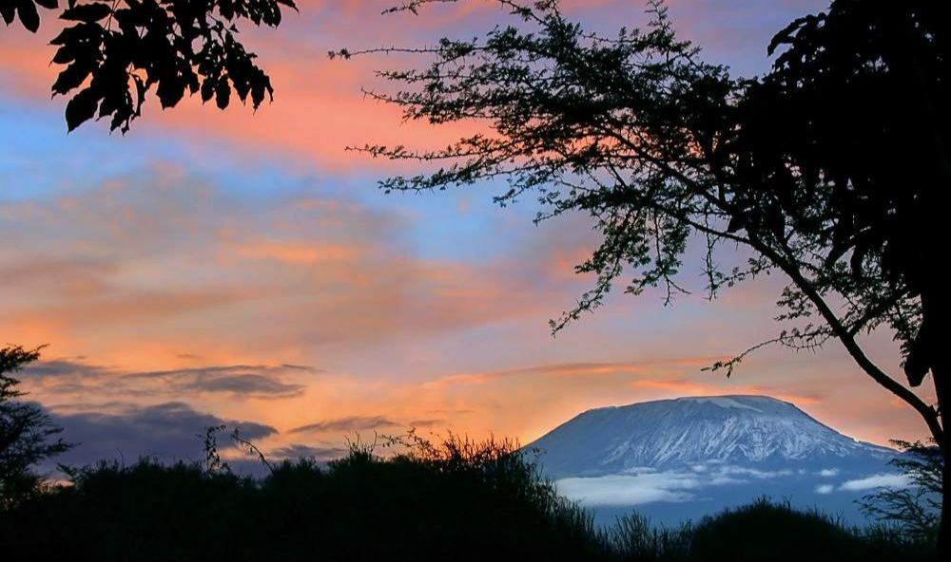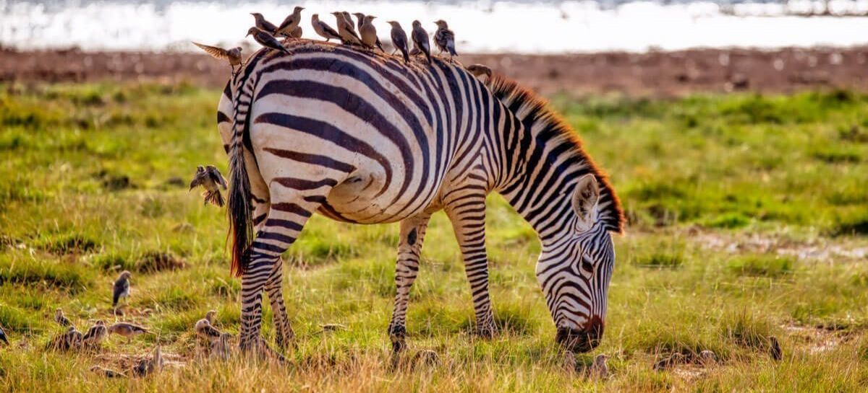

Day 2: Masaai Mara full day game drive:

After breakfast a full day spent game viewing across the rich, tree studded grassland and rolling hills. The famous mara is renowned for its great herds of plain game, black-manned lions, leopard and cheetah but also contains numerous elephant and virtually every type of wild life to be found in Kenya, lunch is served in the park at the Mara river, the boarder of Kenya and Tanzania and the scene for yearly wildebeest migration, after lunch continue with your game drive covering the park into sections, return to the camp for dinner and overnight.

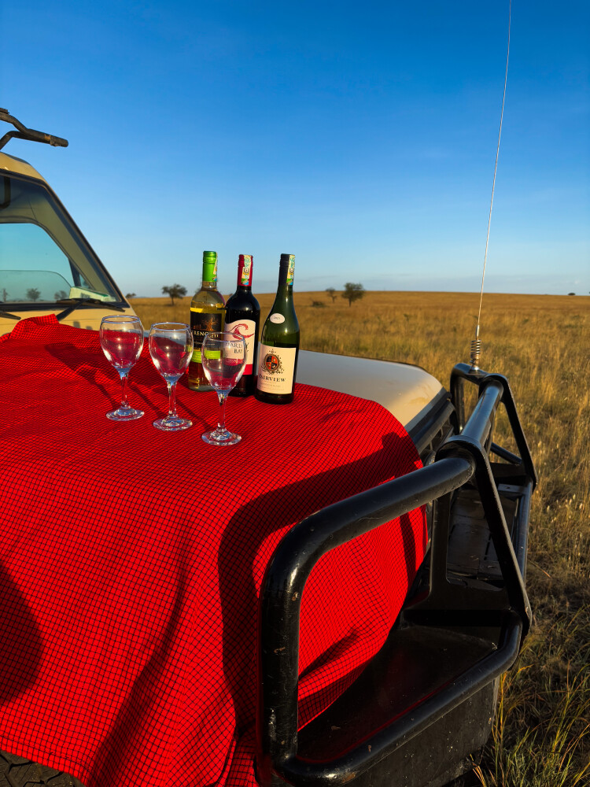

Day 3: Masaai Mara-Lake Nakuru.

Pre breakfast game drive, return to campsite for late breakfast and leave your campsite and proceed to L.Nakuru arriving in the late afternoon for dinner and overnight in Nakuru.
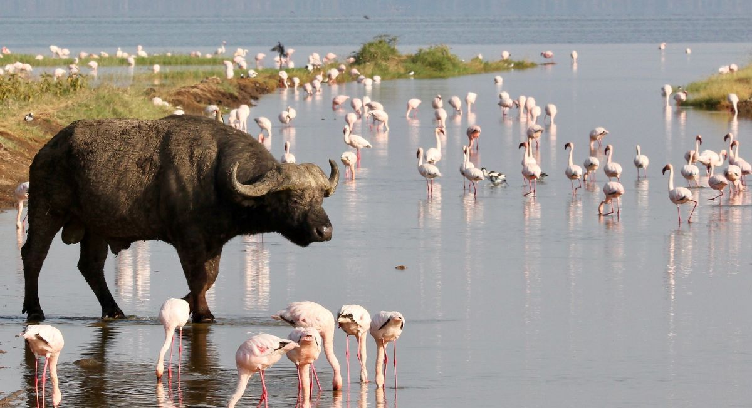

Day 4: Lake Nakuru-Nairobi.

After early morning breakfast proceed for an extensive game drive in Lake Nakuru National park. The park is known to be the bird’s sanctuary, it is so called the pink lake because the entire surface of the lake is covered by both the lesser and greater flamingoes, this park is also known for it’s big five excluding the Elephants, it is the only park in Kenya where you are assured of seeing both the white and the black rhinos. Leave Lake Nakuru after lunch for Nairobi arriving late afternoon for overnight at a hotel on full board basis.

Day 5: Nairobi-Arusha-Lake Manyara.

Pick up from your hotels in Nairobi at 5.00 am for an early drive to Arusha with a stopover at the Namanga border post for immigration formalities, arrive in Arusha around 9:00 am and proceed to Lake Manyara National Park for game drive. A good network of tracks and roads in the park allows excellent game viewing opportunities. Animals seen include buffalo and elephant. Other animals present that can be seen with luck are the tree climbing lions, leopard and black rhino. Lesser flamingos and Egyptian geese are some of the birds seen here. All meals and overnight at the camp.
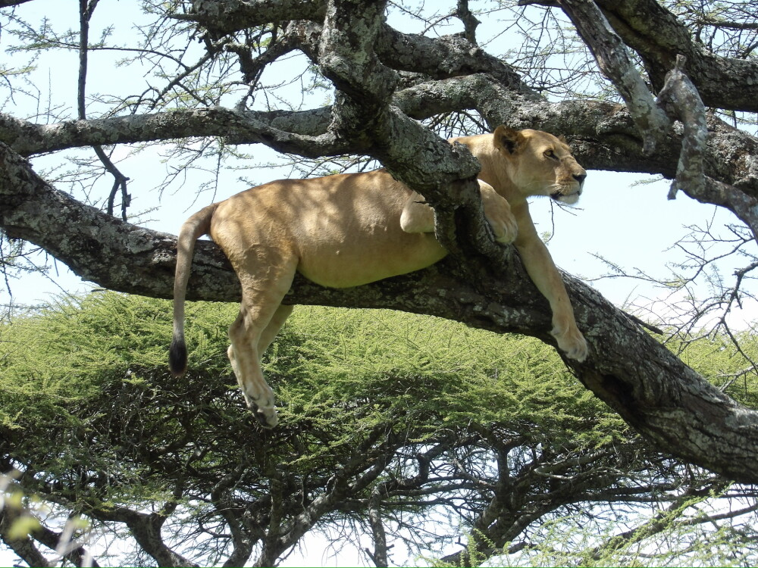

Day 6: Lake Manyara- Ngorongoro Crater.

After breakfast, leave Lake Manyara for Ngorongoro crater arriving in the early afternoon, descending 2000 ft (670m) into the crater floor for a full afternoon crater tour with break for lunch at Ngoitoktok springs picnic site. Black manned lions, rhinos, buffaloes, elephants and other grazing animals abound. Evening game drive, return to Ngorongoro wildlife campsite for dinner and overnight.
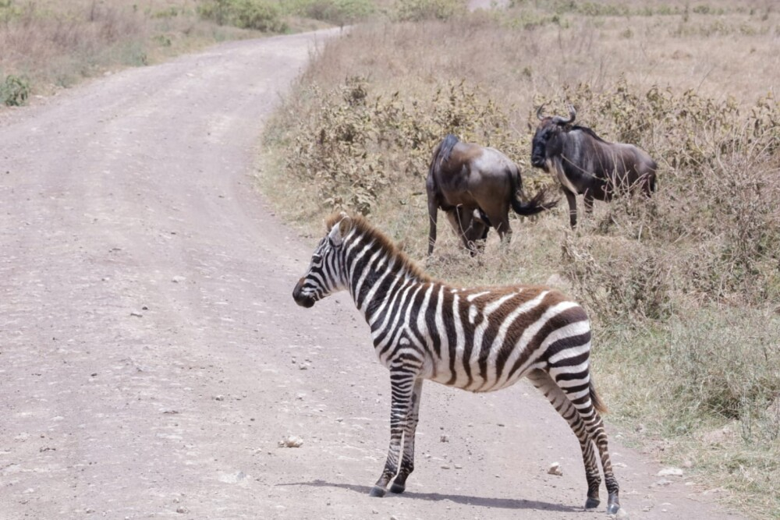

Day 7: Ngorongoro Crater - Serengeti national park:

Leave Ngorongoro crater after breakfast for Serengeti National park arriving in time for lunch after lunch proceed for afternoon game drive in this unique park to see the many animals that are found here, dinner and overnight at Serengeti Seronera camp or similar.
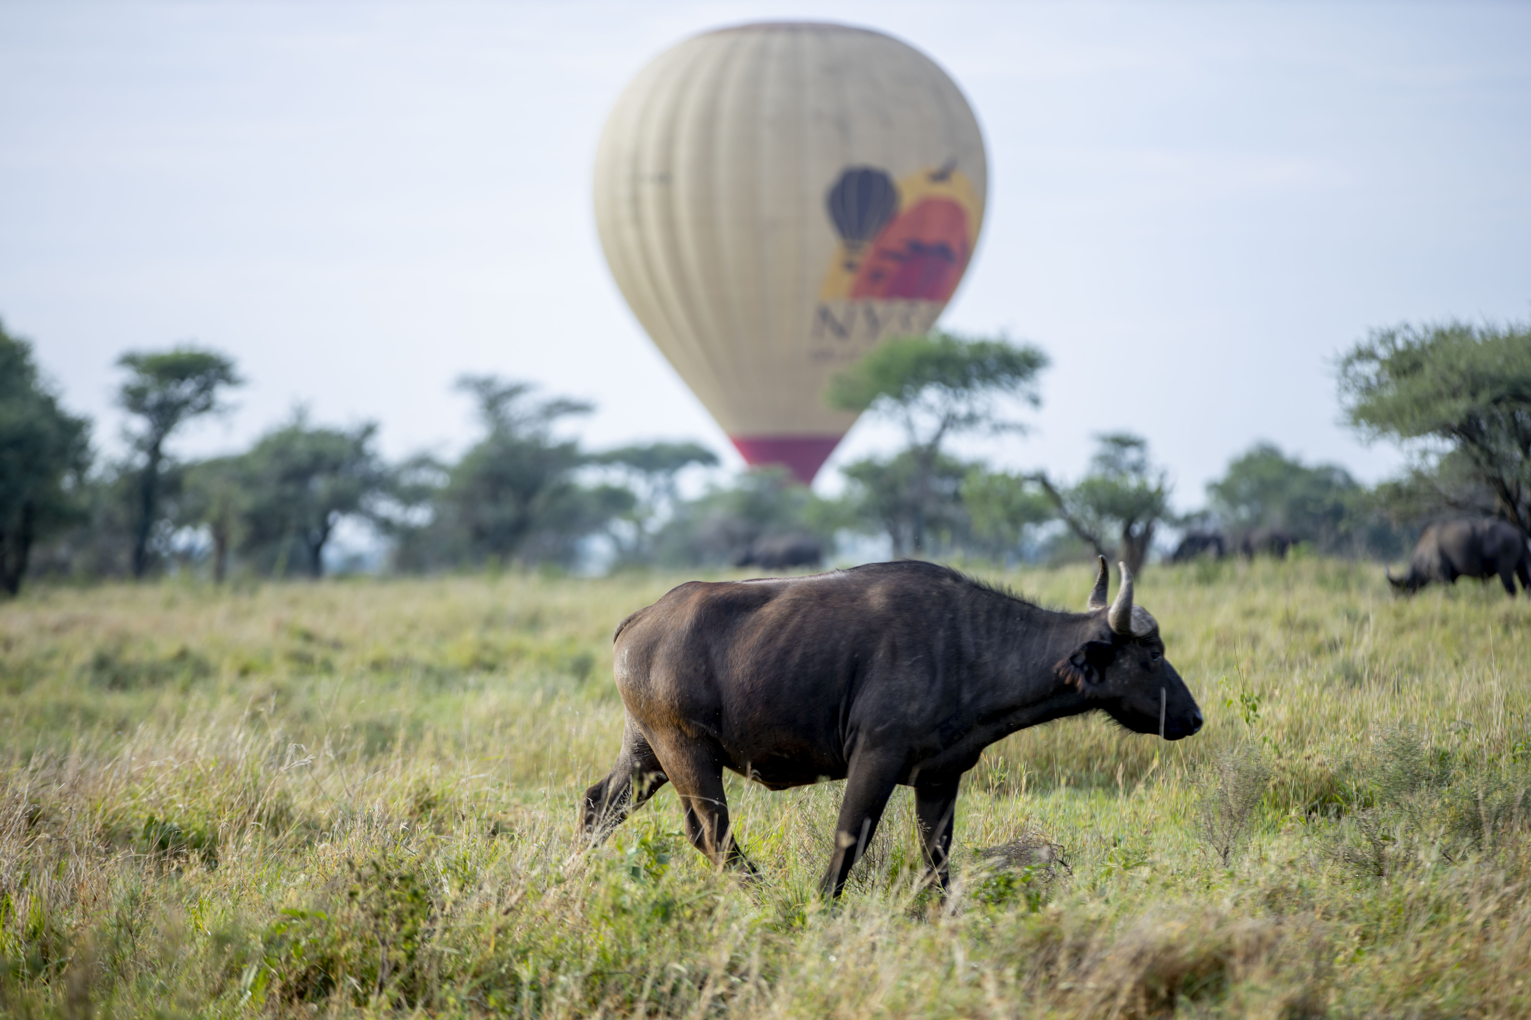

Day 8: Serengeti national park full day game drive:

Morning and afternoon game drive in the Serengeti with a lunch and leisure break at the lodge or campsite in the mid afternoon .The term ‘serengeti’ means endless plains in maasai language. In the central plains there are carnivores like, leopards, hyena and cheetah. This park is normally the scene of the annual migration of the wildebeest and zebras, which occurs between Serengeti and kenya’s maasai mara game reserve. Eagles, Flamingoes, duck, geese, vultures are among the birds that can be seen in the park, Dinner and overnight in your camp.
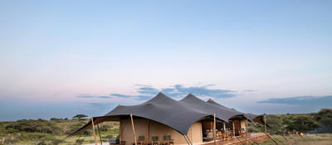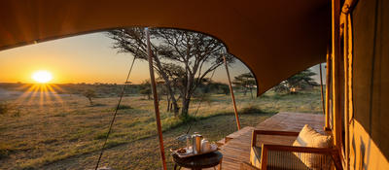

Day 9: Serengeti National park- Arusha
After breakfast leave the camp for your last game viewing on your way out of Serengeti National Park to drive to Arusha via Mto wa Mbu village where the tour ends in the afternoon with sweet memories.

Inclusions:

Transport in a safari 4X4 Land Cruiser jeep customized for game viewing
English speaking Driver/guide,
Game drives
Accommodation in camp
Meals on Full Board Basis while on Safari
Mineral water
All Park Entrance Fees

Exclusions:

Things of personal nature
Soft & alcoholic drinks
International Airfares, Visa Fees
Tips and other gratitude
Optional activities unless specified as included

